OPCC and Wiltshire Police
Job Description

Post Title: Strategic Performance Analyst | Department: OPCC Strategy, Performance and Oversight
Post Number: | Work Location: HQ / Agile
Grade/Salary: W9 | Date: June 2026
Contract: Permanent | Reports to: Head of Strategy, Performance & Oversight

Reporting Structure:

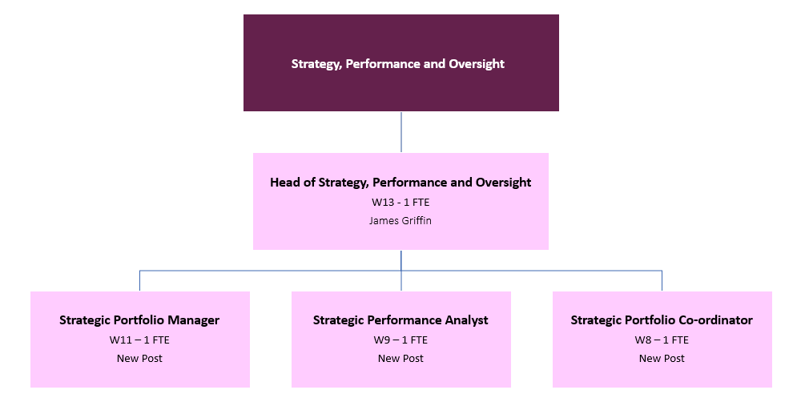

Job purpose
To act as the OPCC’s independent specialist for strategic performance analysis, improvement insight, risk reporting and evidence-based assurance. The postholder is accountable for the quality, integrity and interpretation of analysis used to support senior decision-making, scrutiny and improvement, and provides authoritative judgement on what performance, risk and change evidence means, why it matters and where action is needed.
Main responsibilities
Strategic performance analysis and insight
- Lead the collection, analysis and interpretation of strategic performance information to support scrutiny, accountability, service improvement and executive decision-making.
- Produce high-quality dashboards, reports and briefings that translate complex information into clear insight for senior and non-technical audiences.
- Identify trends, patterns, risks, issues and improvement opportunities, and explain their implications with clear evidence-based recommendations.
- Develop and maintain analytical frameworks, scorecards and approaches that strengthen organisational oversight of performance and improvement.
Improvement, evaluation and change insight
- Analyse change proposals, business cases, benefits plans and improvement activity to support strategic decision-making and organisational assurance.
- Evaluate progress and impact of improvement or change activity, drawing clear conclusions where information is complex, incomplete or ambiguous.
- Support the OPCC to understand whether activity is improving outcomes, strengthening performance and achieving intended benefits.
Strategic risk and assurance
- Maintain the OPCC risk register and produce clear, timely risk reporting for the Head of SPO.
- Monitor and escalate emerging strategic risks affecting performance, delivery, assurance or improvement.
- Provide evidence-based challenge where analysis indicates under-performance, limited progress, weak controls or heightened delivery risk.
Analytical quality and professional standards
- Own and promote analytical quality, integrity and interpretation for SPO reporting and insight.
- Promote evidence-based decisions, good governance, improvement and ethical data handling.
- Work collaboratively with the wider SPO team so that performance analysis informs strategy, portfolio oversight, governance and executive assurance.

Person specification
 | Criteria | Status
Qualifications | Educated to degree level, or able to demonstrate equivalent analytical capability gained through substantial relevant experience. | Essential
 | Relevant qualification or recognised training in performance analysis, business intelligence, risk, service improvement, evaluation or a related discipline. | Desirable
Experience | Experience of analysing strategic performance, risk, improvement or outcomes in policing, criminal justice, local government or a similar service environment. | Essential
 | Experience of producing clear analytical insight for senior audiences, including dashboards, reports, briefings or evaluation products. | Essential
 | Experience of supporting or analysing strategic change, transformation, assurance or service improvement activity. | Essential
 | Experience of evaluation, outcomes monitoring, assurance review or risk-based assessment in a public-service or regulated environment. | Desirable
Skills | Strong analytical skills, including the ability to interpret complex data, identify material messages and present clear insight and recommendations. | Essential
 | Ability to communicate performance, risk and improvement issues clearly, concisely and persuasively to senior and non-technical audiences. | Essential
 | Ability to advise, challenge and influence senior stakeholders through evidence and professional judgement. | Essential
 | Advanced Excel skills and experience with Power BI, Qlik or similar visualisation and analytical tools. | Desirable
Knowledge | Knowledge of performance analysis, improvement methods, evaluation and evidence-based decision-making. | Essential
 | Understanding of performance, improvement and accountability frameworks in public service. | Desirable
 | Knowledge of risk, assurance frameworks and governance good practice. | Desirable

Other Information

Wiltshire Police is committed to safeguarding and promoting the welfare of children and young people and expects all staff and volunteers to share this commitment.

Wiltshire Police have achieved the Disability Confident Leader status as authorised by the Disability Confident National Government Scheme. As a result, any appropriate reasonable adjustments that can be made against any of the above essential/desirable skills and experience will be fully considered and put into place where possible.

Benefits of working for Wiltshire and Swindon PCC:

Flexible working - We believe employees are happier and more productive when they have greater control over their working lives. That is why we will aim to give you the opportunity to fit work around your other responsibilities. We provide mobile technology including laptops and phones. This means you often get the chance to work remotely and flexibly in different locations as required by your role.
Holidays – You will receive at least 25 days' annual leave, rising to 30 days after five years, and 32 days after 20 years, plus public and bank holidays.
Generous Pension – all our new employees are assessed against criteria and automatically enrolled into the Local Government Pension Scheme (unless you choose to opt out).
Learning and Development - Access to a comprehensive learning and development offer using a range of tools and platforms and including 8 hours learning & development time entitlement a month.
Salary sacrifice - schemes which save tax and national insurance – including cycle to work.
Occupational health service - Practical and confidential Occupational Health support for all staff. Police Mutual Health Insurance – Healthcare Scheme. This is an optional benefit, open to all (Staff and Officers) paid via payroll after tax. Not subsidised by the organisation – but competitive rates compared to other private healthcare companies.
Eyecare – Employees can request a voucher to take to their local Specsavers branch, every two years.
EAP – Employee Assistance Program – Health Assured and the Wisdom App. Phone line and app that can support with a range of issues including the following:
Counselling and emotional support / Debt and financial management / Legal and tax advice / Childcare advice / Retirement / Consumer Issues
Onsite gym – gym facilities to use onsite.
Access to the Blue light discount card - for emergency services which provides discounts for high street and online retailers: https://www.bluelightcard.co.uk/
Free parking at police headquarters
Loans/Savings – Processed direct from Pay from our Payroll Team Serve and Protect Credit Union

